**– Pembuatan Database –**

Create Database Pertemuan4_Cahaya;

use Pertemuan4_Cahaya;

create table tbl_buku(

ISBN nvarchar(50),

Judul nvarchar(50),

Pengarang nvarchar(50),

Penerbit nvarchar(50));

**– Design –**



**– Codingan Form1.vb –**

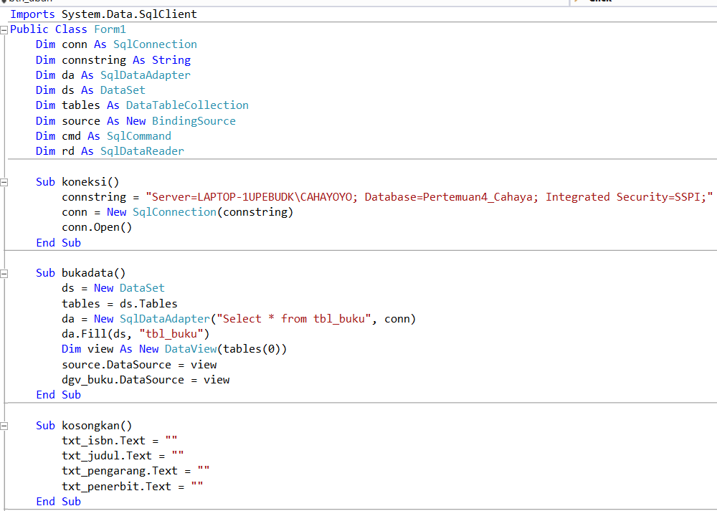

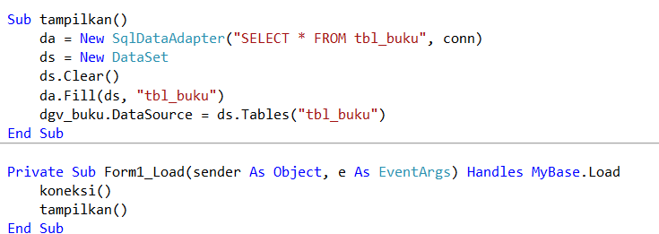

**Dim conn As SqlConnection**

**Dim connstring As String**

**Dim da As SqlDataAdapter**

**Dim ds As DataSet**

**Dim tables As DataTableCollection**

**Dim source As New BindingSource**

**Dim cmd As SqlCommand**

**Dim rd As SqlDataReader**

**Sub koneksi()**

**connstring = "Server=LAPTOP-1UPEBUDK\CAHAYOYO; Database=Pertemuan4_Cahaya; Integrated Security=SSPI;"**

**conn = New SqlConnection(connstring)**

**conn.Open()**

**End Sub**

**Sub bukadata()**

**ds = New DataSet**

**tables = ds.Tables**

**da = New SqlDataAdapter("Select * from tbl_buku", conn)**

**da.Fill(ds, "tbl_buku")**

**Dim view As New DataView(tables(0))**

**source.DataSource = view**

**dgv_buku.DataSource = view**

**End Sub**

**Sub kosongkan()**

**txt_isbn.Text = ""**

**txt_judul.Text = ""**

**txt_pengarang.Text = ""**

**txt_penerbit.Text = ""**

**End Sub**

**Sub tampilkan()**

**da = New SqlDataAdapter("SELECT * FROM tbl_buku", conn)**

**ds = New DataSet**

**ds.Clear()**

**da.Fill(ds, "tbl_buku")**

**dgv_buku.DataSource = ds.Tables("tbl_buku")**

**End Sub**

**– Codingan Button Simpan –**

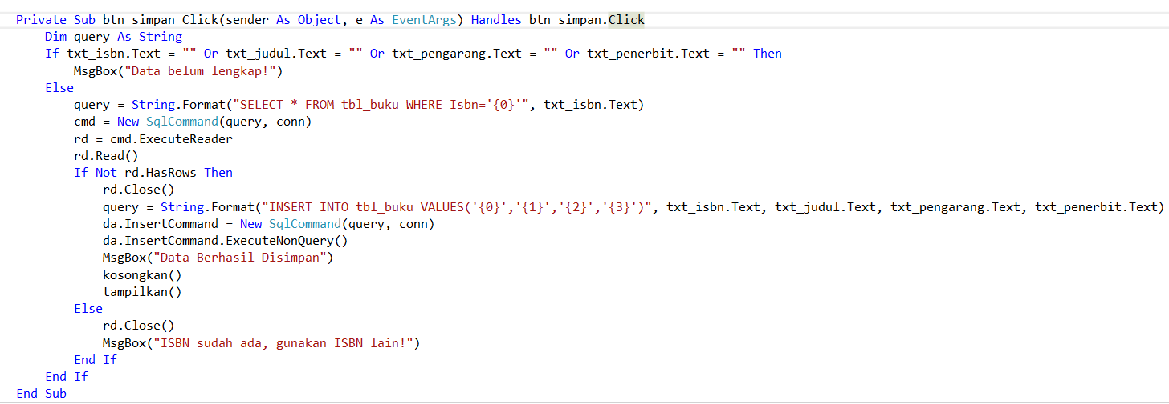

**Dim query As String**

**If txt_isbn.Text = "" Or txt_judul.Text = "" Or txt_pengarang.Text = "" Or txt_penerbit.Text = "" Then**

**MsgBox("Data belum lengkap!")**

**Else**

**query = String.Format("SELECT * FROM tbl_buku WHERE Isbn='{0}'", txt_isbn.Text)**

**cmd = New SqlCommand(query, conn)**

**rd = cmd.ExecuteReader**

**rd.Read()**

**If Not rd.HasRows Then**

**rd.Close()**

**query = String.Format("INSERT INTO tbl_buku VALUES('{0}','{1}','{2}','{3}')", txt_isbn.Text, txt_judul.Text, txt_pengarang.Text, txt_penerbit.Text)**

**da.InsertCommand = New SqlCommand(query, conn)**

**da.InsertCommand.ExecuteNonQuery()**

**MsgBox("Data Berhasil Disimpan")**

**kosongkan()**

**tampilkan()**

**Else**

**rd.Close()**

**MsgBox("ISBN sudah ada, gunakan ISBN lain!")**

**End If**

**End If**

**– Codingan Button Hapus –**

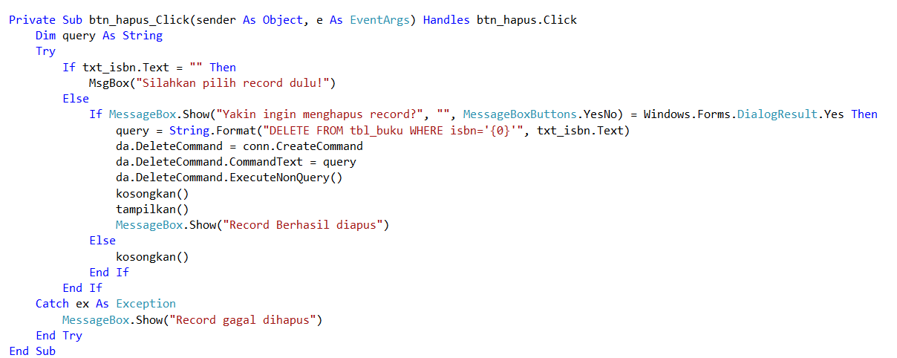

**Dim query As String**

**Try**

**If txt_isbn.Text = "" Then**

**MsgBox("Silahkan pilih record dulu!")**

**Else**

**If MessageBox.Show("Yakin ingin menghapus record?", "", MessageBoxButtons.YesNo) = Windows.Forms.DialogResult.Yes Then**

**query = String.Format("DELETE FROM tbl_buku WHERE isbn='{0}'", txt_isbn.Text)**

**da.DeleteCommand = conn.CreateCommand**

**da.DeleteCommand.CommandText = query**

**da.DeleteCommand.ExecuteNonQuery()**

**kosongkan()**

**tampilkan()**

**MessageBox.Show("Record Berhasil diapus")**

**Else**

**kosongkan()**

**End If**

**End If**

**Catch ex As Exception**

**MessageBox.Show("Record gagal dihapus")**

**End Try**

**– Codingan Button Ubah –**

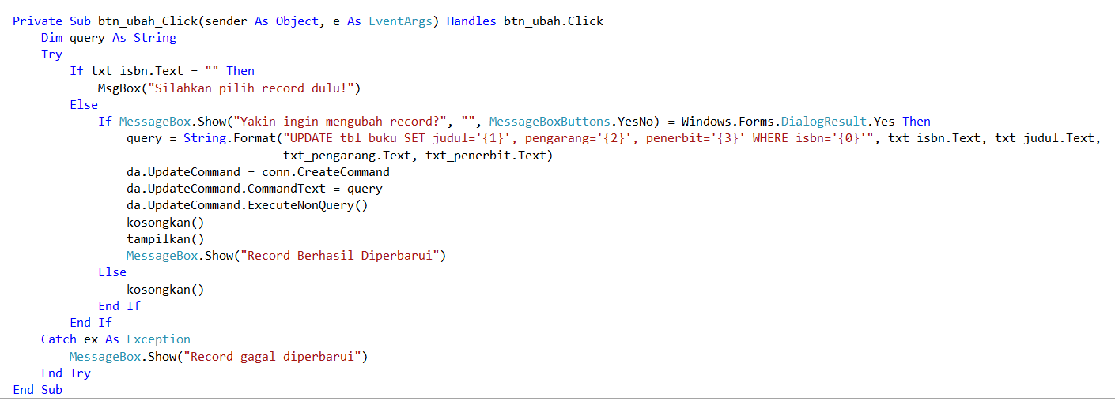

**Dim query As String**

**Try**

**If txt_isbn.Text = "" Then**

**MsgBox("Silahkan pilih record dulu!")**

**Else**

**If MessageBox.Show("Yakin ingin mengubah record?", "", MessageBoxButtons.YesNo) = Windows.Forms.DialogResult.Yes Then**

**query = String.Format("UPDATE tbl_buku SET judul='{1}', pengarang='{2}', penerbit='{3}' WHERE isbn='{0}'", txt_isbn.Text, txt_judul.Text, txt_pengarang.Text, txt_penerbit.Text)**

**da.UpdateCommand = conn.CreateCommand**

**da.UpdateCommand.CommandText = query**

**da.UpdateCommand.ExecuteNonQuery()**

**kosongkan()**

**tampilkan()**

**MessageBox.Show("Record Berhasil Diperbarui")**

**Else**

**kosongkan()**

**End If**

**End If**

**Catch ex As Exception**

**MessageBox.Show("Record gagal diperbarui")**

**End Try**

**– Codingan Button Keluar–**



**– Codingan DataGridView Buku –**

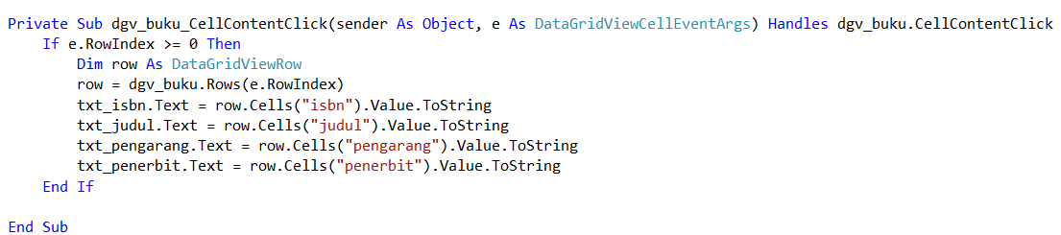

**If e.RowIndex >= 0 Then**

**Dim row As DataGridViewRow**

**row = dgv_buku.Rows(e.RowIndex)**

**txt_isbn.Text = row.Cells("isbn").Value.ToString**

**txt_judul.Text = row.Cells("judul").Value.ToString**

**txt_pengarang.Text = row.Cells("pengarang").Value.ToString**

**txt_penerbit.Text = row.Cells("penerbit").Value.ToString**

**End If**

**Panduan Screenshot**

* **Design**
* **Codingan Koneksi**
* **Codingan Setiap Button**
* **Output Simpan, Ubah, Hapus**